

**Please state Index Number:**

|  |  |  |  |  |
| --- | --- | --- | --- | --- |
| **Student Name:** | | **Asadbek Kenjabaev** | | |
| **Student Number:** | | **B1904039** | | |
| **Course:** | | **Bachelor of Science (Hons) Computer Information Systems for Business** | | |
| **Module Code and Title:** | | **(ICP2052) Application Development** | | |
| **Module Leader:** | | **Mr Mohamed Yatim bin Abdul Ghani** | | |
| **Module Tutor:** | | **Mr Syed Rizwan** | | |
| **Assessment:** | | **Written Assignment** | | |
| **Due Date:** | **30 December 2021** | | **Date Submitted:** | **28 December 2021** |
| **Weighting within Module:** | | **35%** | | |
| **ALL MARKS ARE PROVISIONAL AND ARE SUBJECT TO CHANGE UNTIL CONFIRMED BY THE EXTERNAL EXAM BOARD** | | | | |
| **Comments from Internal Examiner (Name):** | | | | |
| **Strengths:** | | | | |
| **Weaknesses:** | | | | |
| **Areas of Improvement:** | | | | |
| **Provisional Mark out of 100:** | | |  | |
| **ALL MARKS ARE PROVISIONAL AND ARE SUBJECT TO CHANGE UNTIL CONFIRMED BY THE EXTERNAL EXAM BOARD** | | | | |

Contents

Section 1. Problem Statement 3

Section 2. Problem Breakdown Document 3

Section 3. Program Specification 4

Section 4 Algorithm Pseudo Code Listings 6

Section 5 Test Plan for your Own Program 7

References 10

# Section 1. Problem Statement

A POS system's purpose is to assist a corporation enhance the manual processes of processing and monitoring everyday trade transactions by making them more efficient, accurate, and serious. P.O.S. the system will manage orders and client receipts proactively. A Common Obstacle How does one go about developing a computerized point of sale system that can assist a business in processing everyday transactions more effectively and accurately? - A typical issue for supporters is figuring out how to build a computerized sales system that will allow a firm to conduct and analyse its daily transactions in a more effective and precise manner.

Specific Concerns How can I make a module that keeps track of available products? - The system must have a module for maintaining a product inventory that is easily accessible. How do you build a system that protects reports? -The system must be capable of safeguarding company reports. How do you build a system that can provide an accurate sales report for the company's owner? -On a daily, weekly, monthly, and yearly basis, the system must be able to provide an accurate, efficient, and complete report for the owner. How do you build a system that generates receipts for customers? -When necessary, the system should be able to create receipts for customers in the store. How does one go about developing a system that can automatically determine a company's daily sales? -The organization need a computerized system that can calculate total sales automatically and precisely.

# Section 2. Problem Breakdown Document

Scope and Limitation

File maintenance. Manages all information on the system concerning adding, reading, modifying, and removing corporate files.

Product Maintenance - controls the company's available items in the system

Product Category Maintenance -accomplishes the category of products in the system.

Transaction. It oversees all transactions in the system. It contains a list of the clients' items as well as the total cost of their orders.

Report. It is used by the company's administrator/owner to track sales and items sold in their shop.

Reports can be generated weekly or monthly, depending on the administrator's requirements.

Utilities. Only the owner / administrator has access to this menu. It has an Audit Trail submenu as well as a Backup and Restore menu. The system's reference manuals for him are available here.

Help. It comprises all of the information that can assist the user in learning how to utilize the system.

Log off. It takes the user back to the system's Log-in form.

Exit. It enables users to close the entire software.

Receipt (optional). The system can only create a receipt if the consumer buys a substantial quantity of merchandise worth at least 50 pesos. If a consumer spends less than 50 pesos, the cashier will not issue a receipt.

# Section 3. Program Specification

The point of sale or point of purchase is the time and location when the retail transaction is completed. At the point of sale, the seller calculates the amount due by the buyer, displays it, can produce an invoice for the customer, and displays payment choices for the buyer.There are two panels in this system (administrator and staff). This documentation explains how the system works and includes graphics to aid comprehension.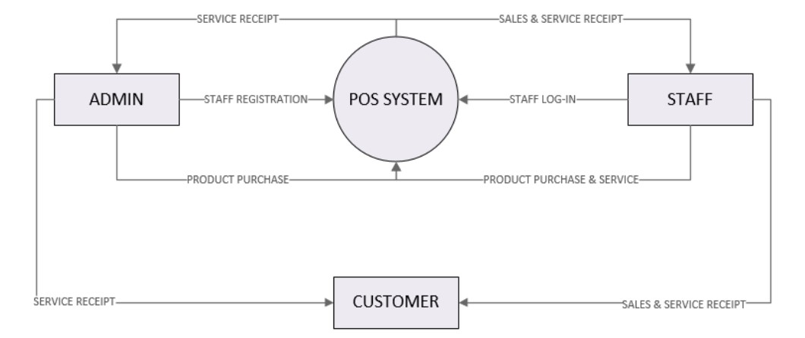

The context diagram of the system's general operation is shown above. The key entities in the diagram are the personnel and the system. By providing the individual's login and password, the administrator may register the personnel through the system. The customer support panel is accessible to the administrator. After successfully completing the task, the administrator must deliver the customer service receipt to the customers. Furthermore, in order to have access to the system, employees must register with a unique login and password. They can then proceed to market and provide new items. Upon completion, they will give customers a copy of the purchase receipt as well as any service receipts. Employees can, once again, alter customer service records upon request. We take a deeper look at the POS system's capabilities in the diagram below.

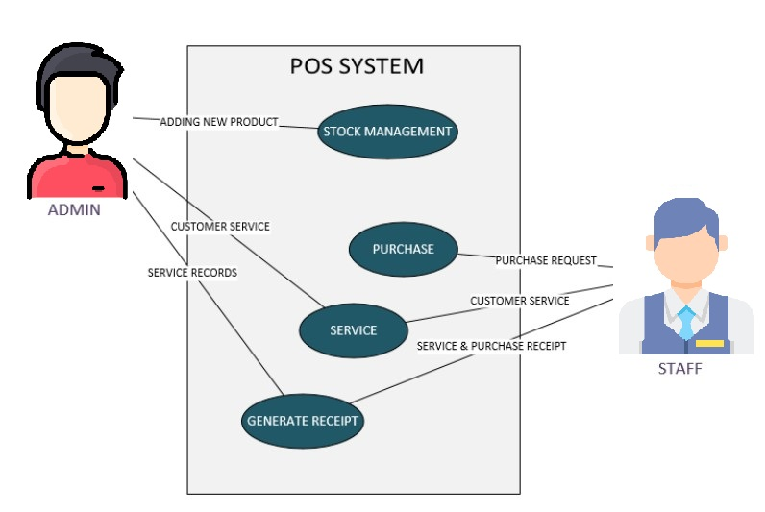

|  |  |
| --- | --- |
| Name | Stock Management |
| Actor | Admin |
| Desciption | Described the procedure for adding a new stock. |
| Successful Completion | 1. The administrator has the ability to add new stock.  2. Employees can view the most recent stock report. |
| Alternative | None |
| Precondition | Admins must first register their account and password. |
| Post Condition | Admin has added stock. |
| Assumption | None |

|  |  |
| --- | --- |
| Name | Purchase |
| Actor | Staff |
| Desciption | Describe the system's purchasing procedure. |
| Successful COMPLETION | 1.Customers might be sold new products by employees.  2. Employees will be given a purchase receipt. |
| Alternative | None |
| Precondition | Staff must first register |
| Post Condition | The customer bought the goods. |
| Assumption | None |

|  |  |
| --- | --- |
| Name | Service |
| Actor | Admin & Staff |
| Desciption | Describe the procedure of customer service |
| Successful Completion | 1. Staff & Admin can offer service to its customer  2. Staffs & Admin will accept service receipt |
| Alternative | Either Staffs or Admin has access to service |
| Precondition | Staffs & Admin need to be register first |
| Post Condition | Existing customers |
| Assumption | None |

|  |  |
| --- | --- |
| Name | Creating Receipt |
| Actor | Admin & Staff |
| Desciption | Define the procedure used to make the receipt (Sales & Service) |
| Successful Completion | 1. Staff & Admin can provide service to its buyer  2. Staffs & Admin will obtain service receipt |
| Alternative | Either Staffs or Admin can access service |
| Precondition | Existing customers |
| Post Condition | Clients receive the after sales service |
| Assumption | None |

# Section 4 Algorithm Pseudo Code Listings

1. Database searching algorithm pseudocode used in Search products category.

if (set(minprice) and minprice != 'nomin')

conditions[] = 'price > minprice'

if (set(maxprice) and maxprice != 'nomax')

conditions[] = 'price < maxprice'

query = 'select * from table'

if (notempty(conditions))

query += ' where '+conditions.join(' and ')

2. “Algorithm pseudocode for access account.

Initialize the Login Account

Enter Username or Login Id

In the First place section: Enter Password

If

The username, Password synchronizes and are authenticated,

Then

Confirmation approval by Admin.

Else

Id or Password may be invalid or wrong

Try again

If

The Password is Valid, Verification approval by Admin.

Then

Access to the Login Account

# Section 5 Test Plan for your Own Program

**Test 01**

**Title** : Stock Management Button

**Procedure** : Click on the button MANAGE STOCK

**Data**: Users need to click on the button

**Expected** **Result**: It will redirect to admin stock management panel

**Test 02**

**Title** : Sales Report Button

**Procedure** : Click on the button SALES REPORT

**Data**: Users need to click on the button

**Expected Result**: It will redirect to admin sales report panel

**Test 03**

**Title** : Add Item

**Procedure** : Click on the button ADD PRODUCT

**Data**: Users need to click on the button

**Expected Result**: It will save the new product details into the database

**Test 04**

**Title** : Update Item

**Procedure** : Click on the button UPDATE

**Data**: Users need to click on the button

**Expected** **Result**: It will update the product details of the stock

**Test 05**

**Title** : Delete Item

**Procedure** : Click on the button DELETE

**Data**: Users need to click on the button

**Expected Result**: It will delete the product records from the stock

**Test 06**

**Title** : Staff Registration

**Procedure** : Click on the button REGISTER

**Data**: Users need to click on the button

**Expected Result**: System will register new staff

**Test 07**

**Title** : Admin View Stock Report

**Procedure** : Click on the button VIEW REPORT

**Data**: Users need to click on the button

**Expected** **Result**: System will view all the records of the stock

**Test 08**

**Title** : Staff Customer Service Adding

**Procedure** : Click on the button ADD SERVICE

**Data**: Users need to click on the button

**Expected** **Result**: New customer service will be added into the database

**Test 09**

**Title** : Staff Service Report

**Procedure** : Click on the button SERVICE REPORT

**Data**: Users need to click on the button

**Expected Result**: System will show all the records of customer service

**Test 10**

**Title**: Staff Update Service

**Procedure**: Click on the button UPDATE SERVICE

**Data**: Users need to click on the button

**Expected Result**: System will update customer service through staff panel” (Sort and Implementation, 2021)

# References

1. Sort, C. and Implementation, P., 2021. *algorithm Tutorial => Pseudocode Implementation*. [online] Riptutorial.com. Available at: <https://riptutorial.com/algorithm/example/24967/pseudocode-implementation> [Accessed 28 December 2021].